AY2025-26
Executive Members

Sr.No. | Name | Post | Photo
1 | Utsav Maradia | 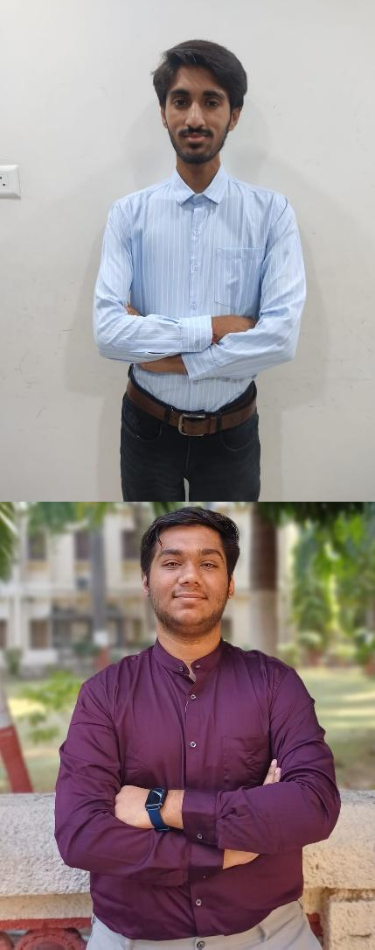  Secretary | 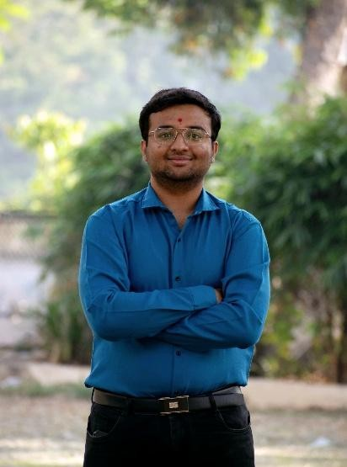
2 | Ruchit Soni | Joint Secretary
3 | Anshul Majumdar | Joint Secretary

4 | Smit Talaviya | Treasurer | 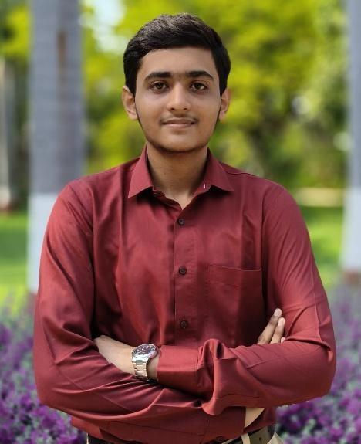
Branch Coordinators

Sr.No. | Branch Name | Student Name | Photo
1 | Mechanical | Satheesh Nadar | 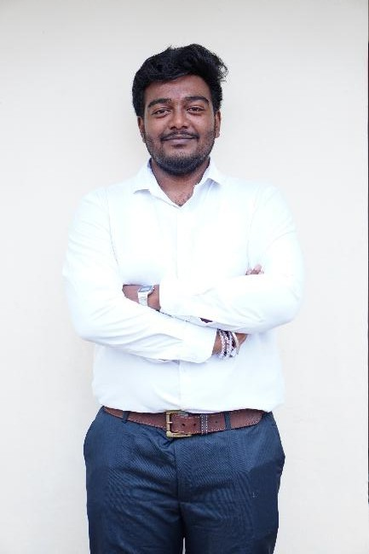

2 | E.C | 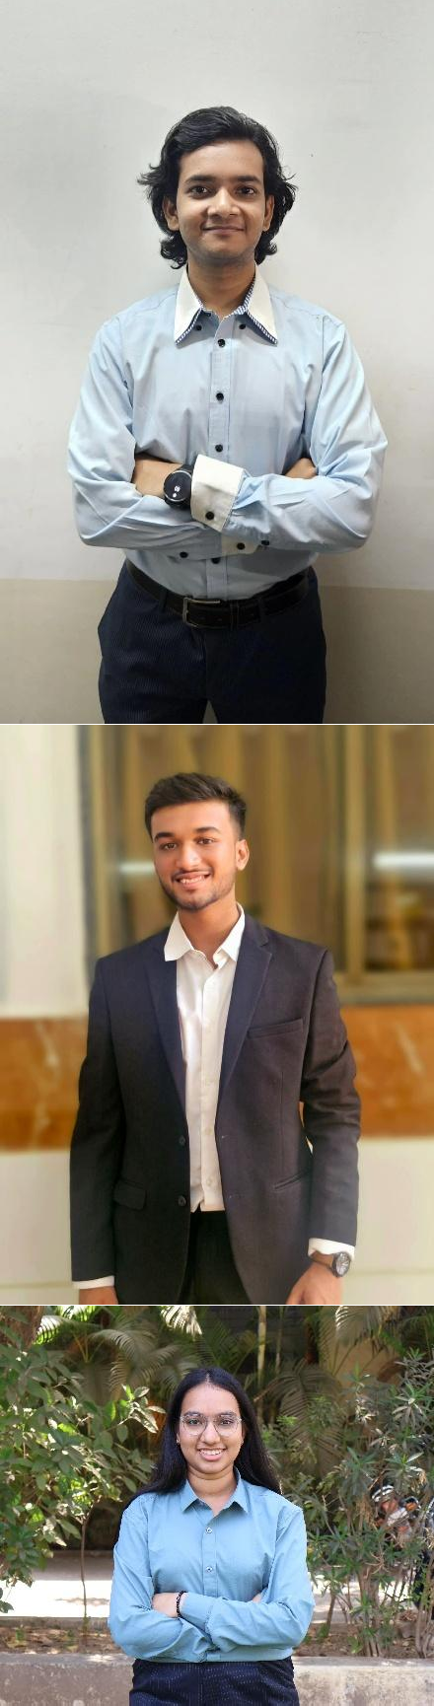  Het Desai
3 | Electronics | Deep Maheshwari
4 | Electrical | Ayushi Faldu

5 | Computer/I.T | Divij Rana | 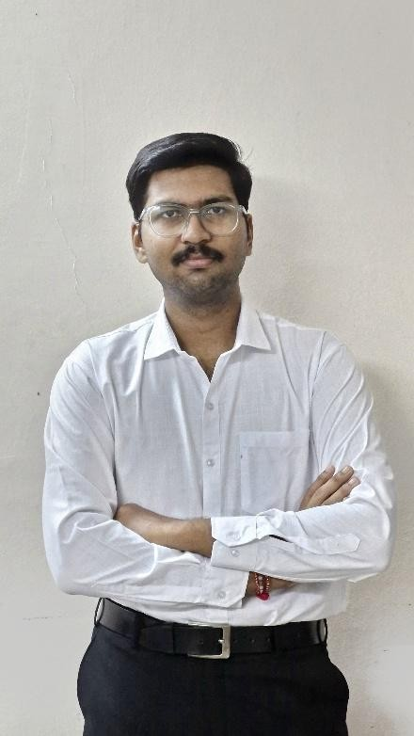

Finance And Inventory Leads

Sr.No. | Name | Photo
1 | Prem Kansara | 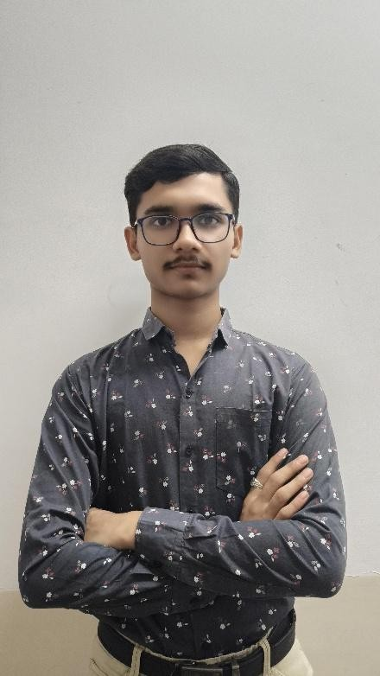

Documentation Leads

Sr.No. | Name | 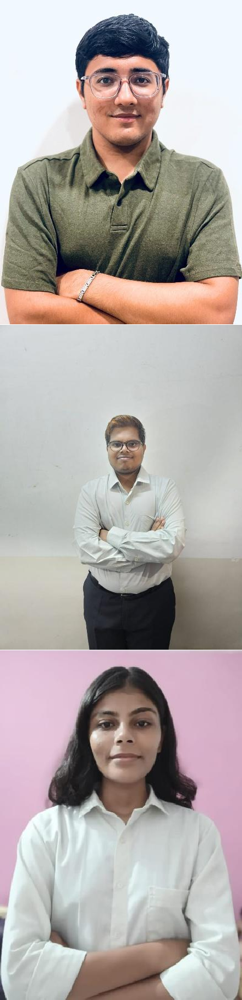  Photo
1 | Yash Gandhi
2 | Yagnik Vadaliya
3 | Dhruti Trivedi

Graphics Leads

Sr.No. | Name | Photo
1 | Mohit Kapadiya | 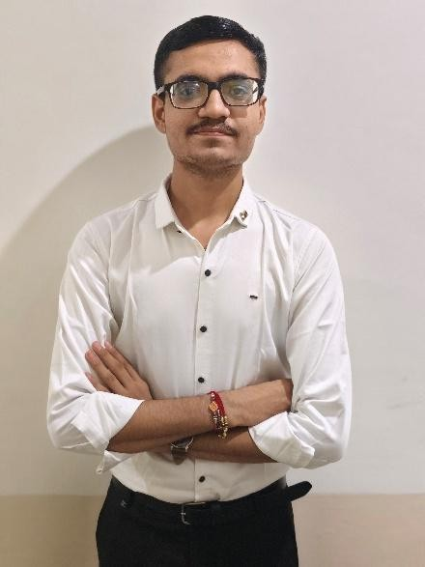
2 | 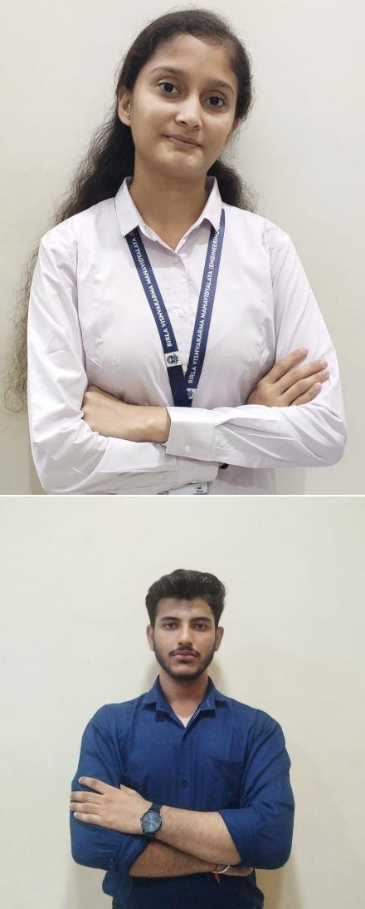  Maitri Chahuan
3 | Harshil Shah

Social Media

Sr.No. | Name | Photo
1 | Tirth Prajapati | 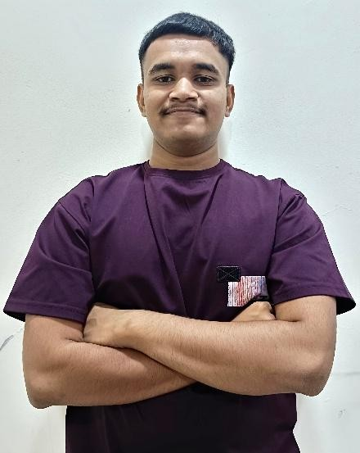

Web Turtles

Sr.No. | Name | Photo
1 | Prachi Bachani | 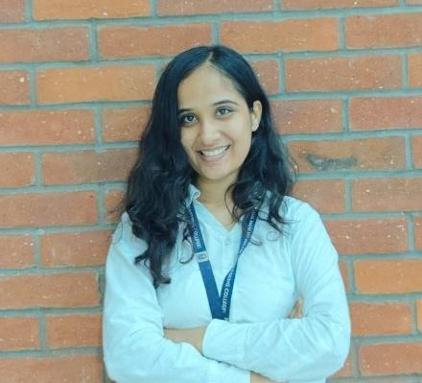
Photography

Sr. No | Name | Photo
1. | Kishan Mori | 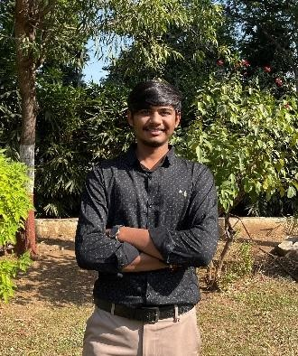

2. | Rushik Javaya | 